AI BLOG NEST- Generate high-quality blog content using AI.
PROJECT DOCUMENTATION

PROJECT OVERVIEW
BlogNest is an AI-powered backend system designed to simplify blog creation, content management, and publishing through a secure REST API. The system is developed using Node.js and Express.js, with MongoDB as the primary database and Mongoose as the Object Data Modeling (ODM) layer.
The application combines traditional blog management features with Generative AI capabilities. Users can create and manage blog posts, organize content, handle comments, and use AI-assisted features such as blog generation and content summarization.

Key Objectives
- Provide secure user registration and login using JWT authentication.
- Support role-based access for Admin, Editor, Author and Reader users.
- Provide complete CRUD operations for blog content.
- Allow blogs to be organized using categories and tags.
- Support comment creation and moderation.
- Provide AI-assisted blog generation and blog summarization.
- Maintain secure and validated data using Mongoose schemas.
- Provide a modular and scalable REST API architecture.
- Protect the application using input validation, sanitization and rate-limiting mechanisms.

Target Users
- Authors who create and manage blog posts.
- Editors who review and manage content before publication.
- Administrators who manage users, roles and system-level operations.
- Readers who consume published blogs and submit comments.
- Students and developers learning REST API, MongoDB, authentication and AI integration.

PROJECT REQUIREMENTS

Software Requirements
S.No | Software / Technology | Purpose
1 | Windows 10/11, macOS or Linux | Operating system for development and execution
2 | Node.js v16 or above | Runtime environment for backend execution
3 | npm v8 or above | Package and dependency management
4 | Express.js | Backend web framework and REST API routing
5 | MongoDB | NoSQL database for users, posts and related data
6 | Mongoose | Schema modeling and MongoDB interaction
7 | Postman / Thunder Client | API testing
8 | Visual Studio Code | Code editor / development environment

Hardware Requirements
- Processor: Intel Core i5 (8th Gen or above) / AMD Ryzen 5 or equivalent.
- RAM: 8 GB minimum; 16 GB recommended for smoother development.
- Storage: At least 1 GB of available project workspace.

Knowledge Requirements
- Basic JavaScript and ES6 concepts.
- Node.js and Express.js REST API development.
- MongoDB and Mongoose ODM.
- JWT-based authentication.
- Middleware and MVC architecture.
- Basic understanding of API testing.

PROJECT ARCHITECTURE
BlogNest follows a modular backend architecture. Incoming API requests are received by the Express server, passed through authentication and authorization middleware where required, processed by controllers and services, and finally stored or retrieved through Mongoose from MongoDB.

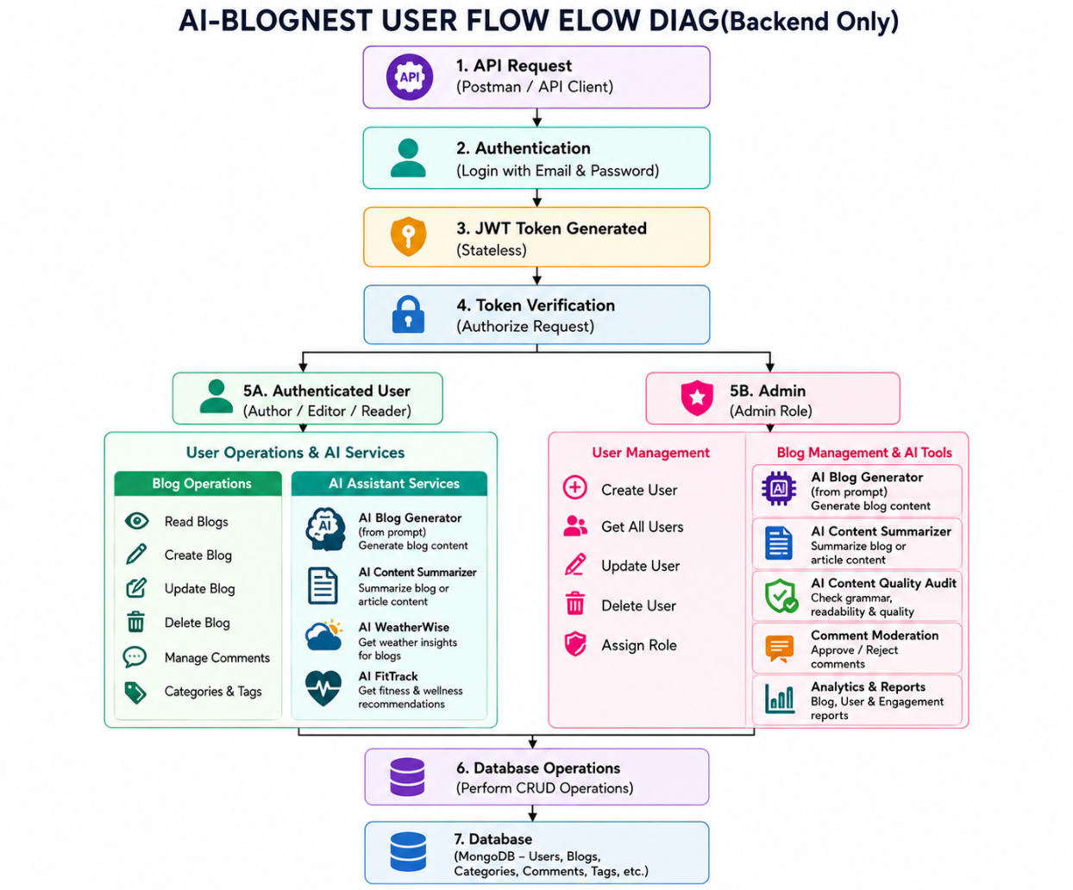

Entity-Relationship (ER) Diagram Description
The BlogNest database consists of multiple collections that store and organize information about users, blog posts, comments, categories, tags, and other related content. These collections are connected through logical relationships to maintain proper data organization and support the different features of the application.
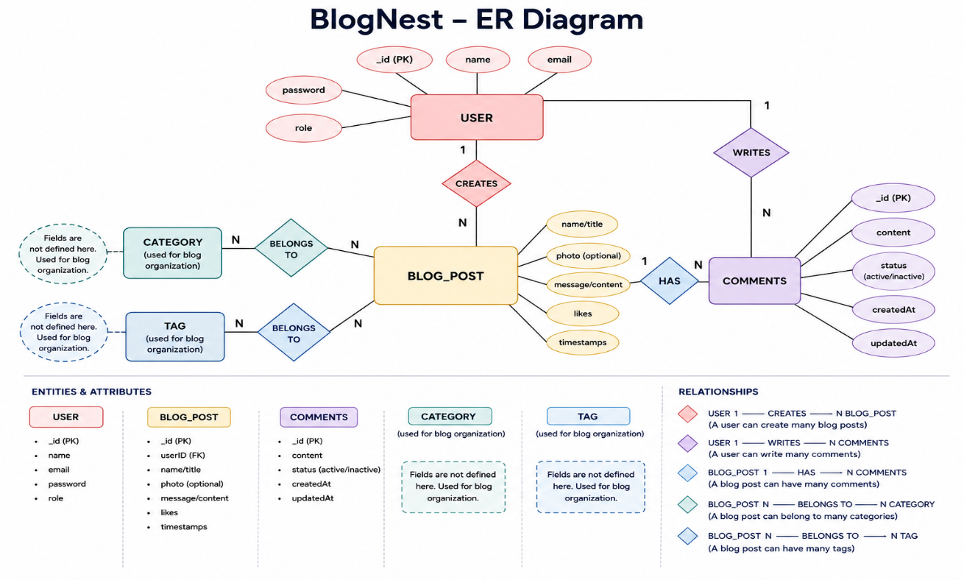

1. User Entity

_id (Primary Key - ObjectId)

name (String, Required)

email (String, Required, Unique)

password (String, Hashed, Required)

role (String, Default: "reader")
2. Post Entity
- _id (Primary Key - ObjectId)
- userID (Foreign Key referencing User Collection)
- name (String, Required - Blog Title)
- photo (Object/String - Image or Media Path)
- message (String - Blog Content)
- likes (Number, Default: 0)
- timestamps (Enabled)

3. Logical Relationships
- One User → Many Posts: An author can create multiple blog posts.
- One User → Many Comments: A user can submit multiple comments.
- One Post → Many Comments: A blog post can receive multiple comments.

FEATURES

Core Features
- User Registration and Login
- JWT-based Authentication
- Role-Based Authorization
- Blog CRUD Operations
- Categories and Tags
- Comment Management and Moderation
- Media Metadata Handling
- Advanced Search
- AI Blog Generation
- AI Blog Summarization
- Input Validation and Sanitization
- Centralized Error Handling

Role-Based Responsibilities
Role | Responsibilities
Admin | Manage users, roles, comments, system-level operations and logging.
Editor | Review pending content, manage publication status and categories.
Author | Create and manage blog posts associated with the author's account.
Reader | Read published blogs and submit comments.

User Flow:

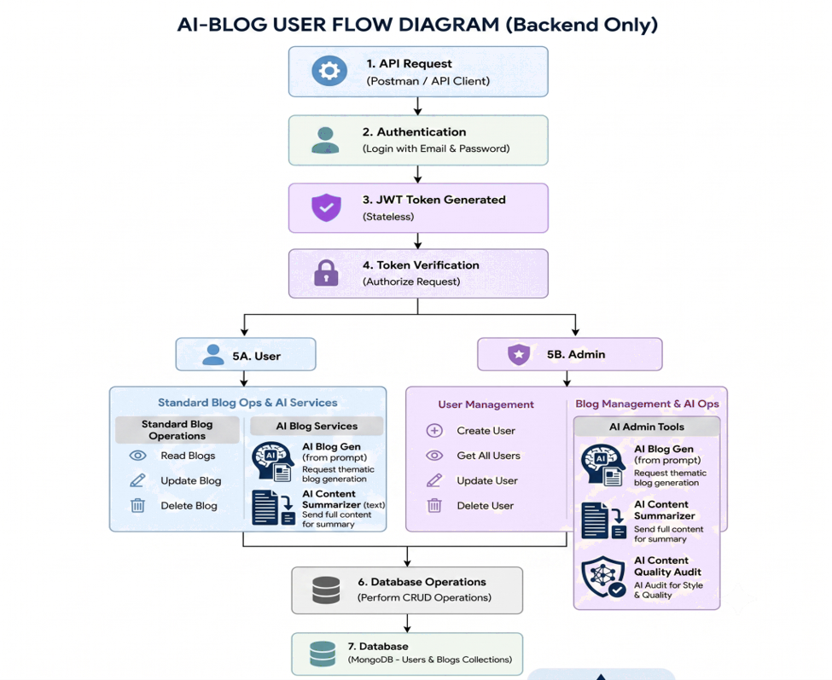

MVC Architecture Pattern
BlogNest uses an MVC-style organization to separate data, application logic and API routing. Because the project is a headless backend, the View layer is represented by the API interface rather than traditional HTML templates.

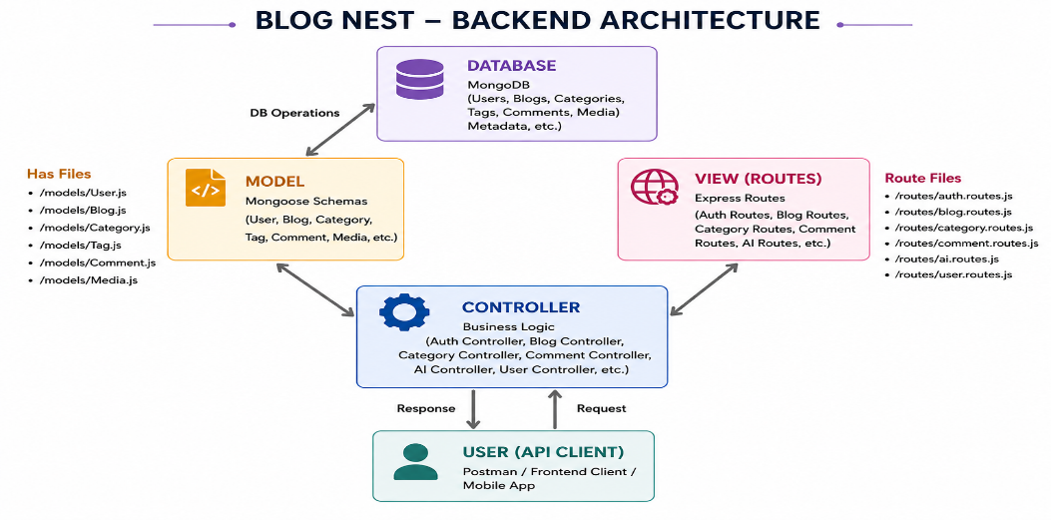

AI INTEGRATION
BlogNest integrates Google Gemini AI to provide intelligent content assistance. The AI layer is connected through specialized backend endpoints so that the controller layer can request AI processing without directly mixing AI logic with the rest of the application.

AI-Powered Blog Generation
The blog generation feature accepts a high-level topic or content request and uses the AI service to produce structured blog content. This reduces the manual effort required to prepare an initial draft.

AI Blog Summarization
The summarization feature processes an existing blog and produces a shorter summary. This can be used to create concise descriptions or provide readers with a quick understanding of longer content.

AI API Endpoints
Endpoint | Purpose
POST /api/ai/generate-blog | Generate blog content using the AI service.
POST /api/ai/summarize | Generate a concise summary from blog content.

SECURITY AND VALIDATION
- JWT tokens are used for stateless authentication.
- bcrypt.js is used for secure password hashing.
- Role-based authorization protects restricted operations.
- Request validation checks incoming data before processing.
- Input sanitization helps reduce unsafe payloads and injection risks.
- Rate limiting helps control excessive requests.
- Centralized error handling provides consistent API error responses.
- Structured logging supports monitoring and troubleshooting.

USER FLOW
- User registers an account with name, email and password.
- The backend validates the registration data.
- The password is securely hashed before storage.
- User logs in using registered credentials.
- The backend verifies the credentials and generates a JWT token.
- The client sends the token when accessing protected endpoints.
- Authentication middleware verifies the token and identifies the user.
- Authorization middleware checks whether the user's role can perform the requested operation.
- The controller processes the request and interacts with MongoDB through Mongoose.
- The backend returns a JSON response to the client.

PROJECT SETUP AND CONFIGURATION

Creating the Project Folder
- Create a new folder for the BlogNest project.
- Create a Server folder inside the project folder.
- Open the project folder in Visual Studio Code.
- Open the Server folder in the VS Code terminal.

Initialize Node.js Project
npm init -y

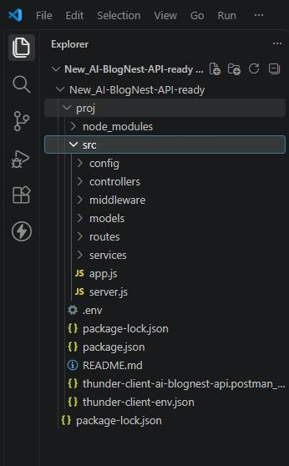

Create files: server.js
Create folders:
- models
- controllers
- routes

Backend Development:
Server.js
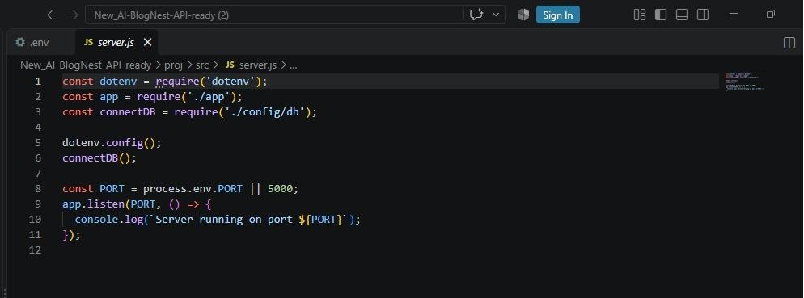

App.js
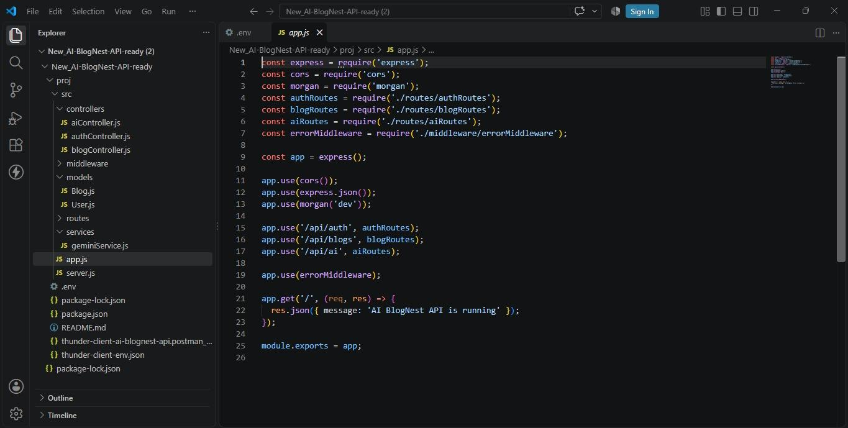

Database Configuration
DB Connection:-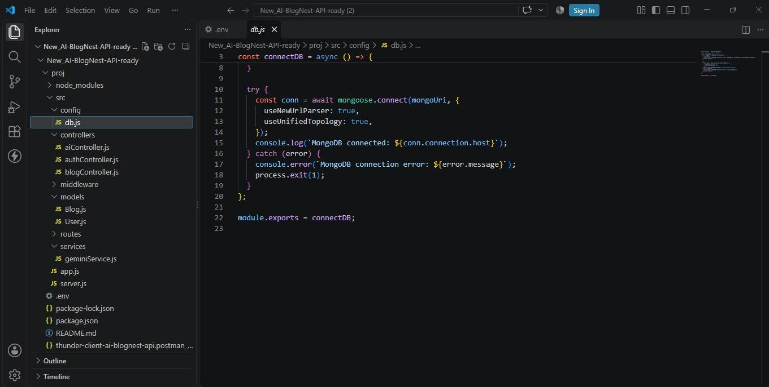

1. Configure MongoDB:
- Install Mongoose.
In your Node.js project directory, run:
npm install mongoose
- Create database connection.
- Create Schemas & Models.

Create Database connection:
Now, make sure the database is connected before performing any of the actions through the backend. The connection code looks similar to the one provided below

Mongoose Schema Definitions

1. Identity Resource Document Schema (schemas/userModel.js)
Enforces field criteria validations on incoming database creations:
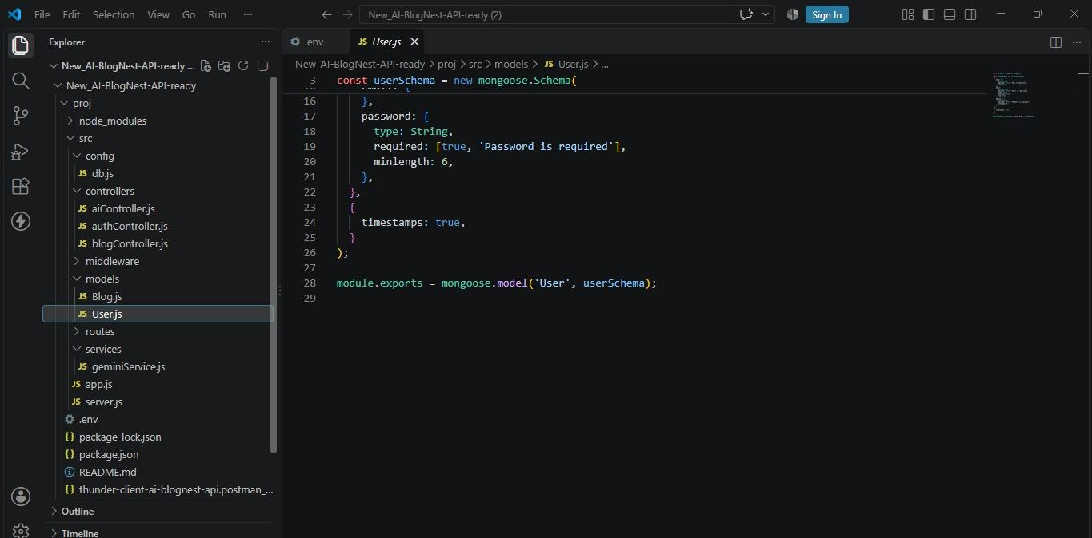

Project Executions:
Install Postman or ThunderClient (VS Code extension).
Start the backend server:
“npm start”
API Testing
User Registration :
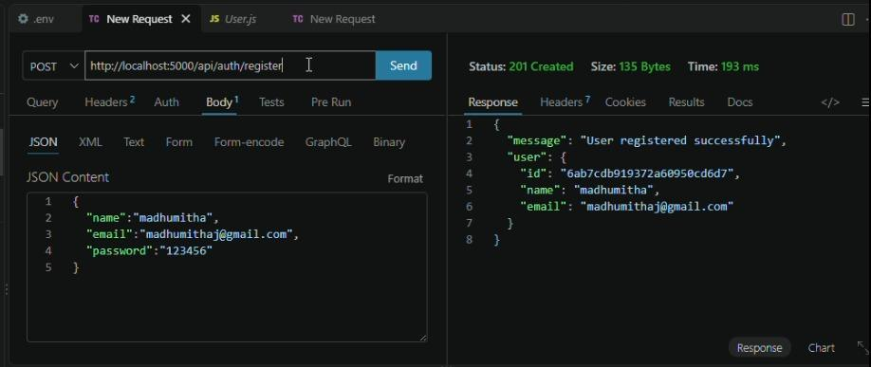

User Login:
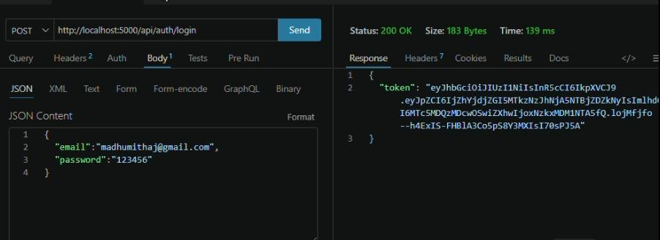

Create Blogs :
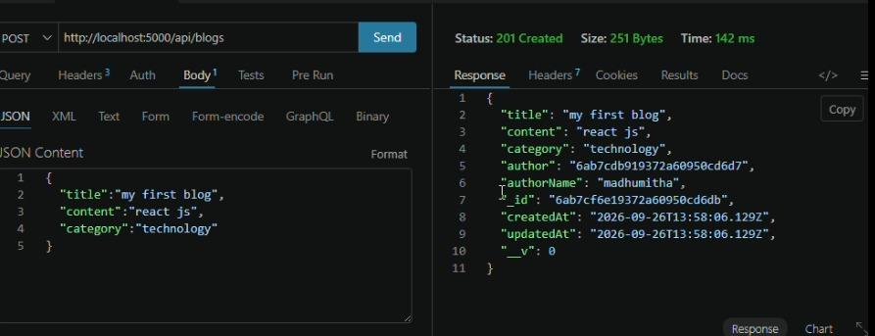
Generate AI blogs :
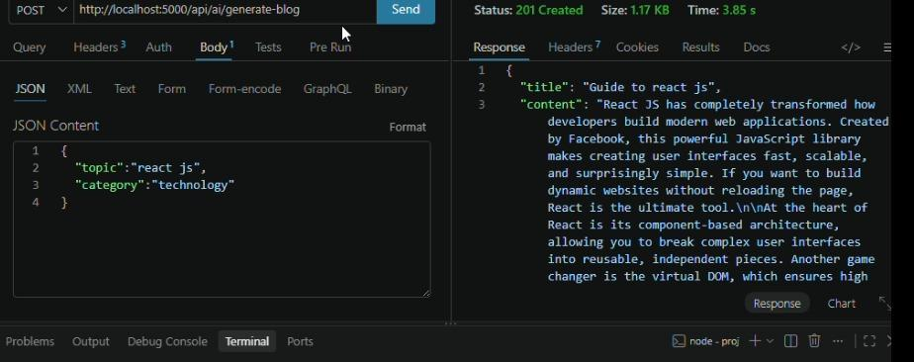

Summarize Blogs :
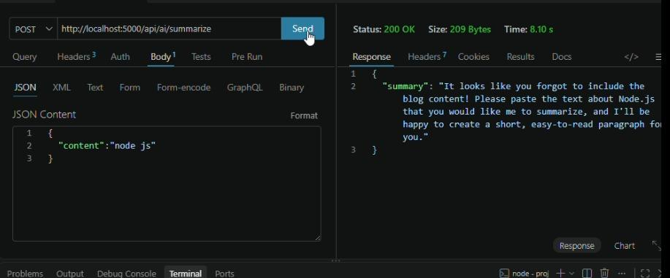
DemoVideo:https://drive.google.com/file/d/1EuAr91UzdqlgXt0jctYAKIe0eKfpecTD/view?usp=drivesdk
API Testing: https://drive.google.com/file/d/1EuAr91UzdqlgXt0jctYAKIe0eKfpecTD/view?usp=drivesdk
CodeDrive : https://drive.google.com/file/d/1EuAr91UzdqlgXt0jctYAKIe0eKfpecTD/view?usp=drivesdk

